**Tugas3**

**(Membuat Web Sederhana)**



**Disusun Oleh :**

Arief Nauvan Ramadha

Junior Web Developer A

**PELATIHAN VSGA**

**JUNIOR WEB DEVELOPER**

**DIGITAL TALENT SCHOLARSHIP**

**2021**

**Nomer 1**

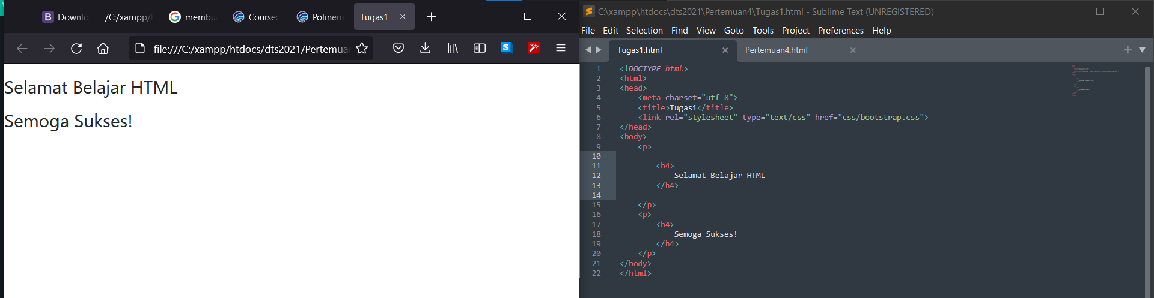

|  |
| --- |
| **<!DOCTYPE html>**  **<html>**  **<head>**  **<meta charset="utf-8">**  **<title>Tugas1</title>**  **<link rel="stylesheet" type="text/css" href="css/bootstrap.css">**  **</head>**  **<body>**  **<p>**    **<h4>**  **Selamat Belajar HTML**  **</h4>**    **</p>**  **<p>**  **<h4>**  **Semoga Sukses!**  **</h4>**  **</p>**  **</body>**  **</html>** |

**Nomer 2**

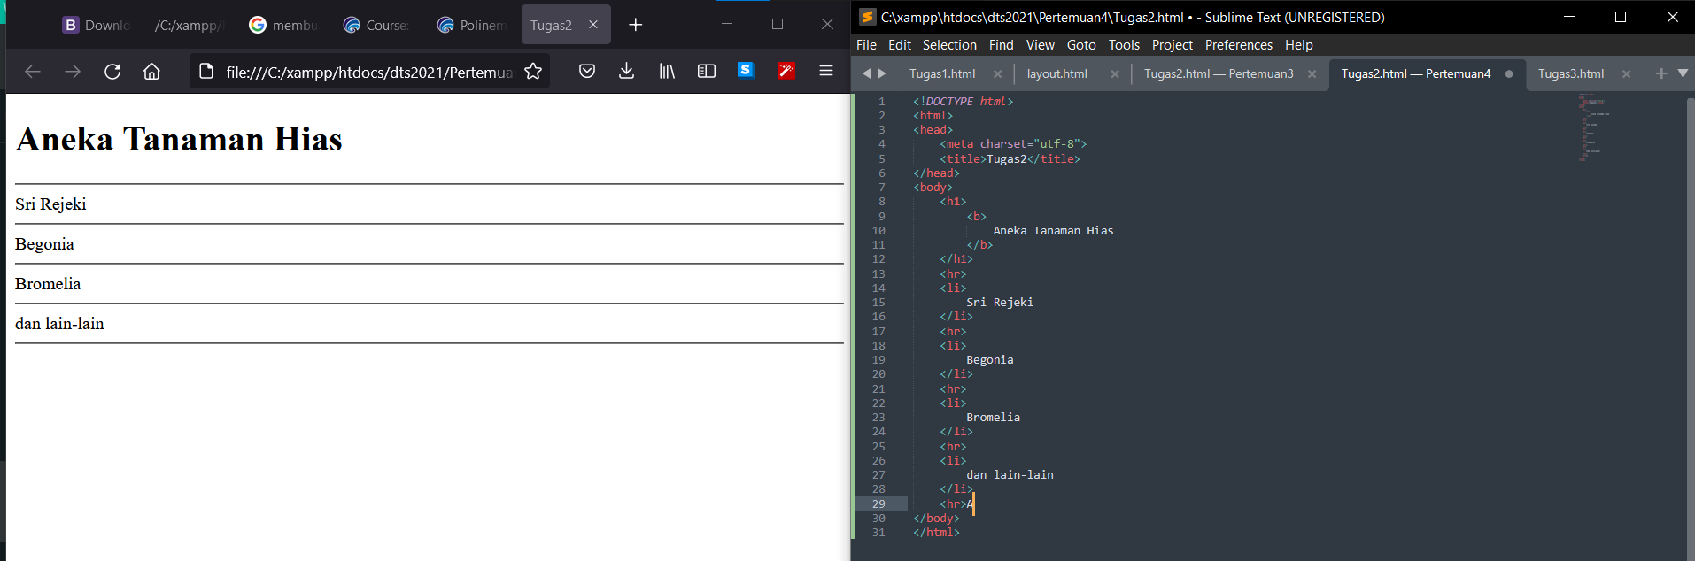

|  |
| --- |
| **<!DOCTYPE html>**  **<html>**  **<head>**  **<meta charset="utf-8">**  **<title>Tugas2</title>**  **</head>**  **<body>**  **<h1>**  **<b>**  **Aneka Tanaman Hias**  **</b>**  **</h1>**  **<hr>**  **<li>**  **Sri Rejeki**  **</li>**  **<hr>**  **<li>**  **Begonia**  **</li>**  **<hr>**  **<li>**  **Bromelia**  **</li>**  **<hr>**  **<li>**  **dan lain-lain**  **</li>**  **<hr>**  **</body>**  **</html>** |

**Nomer 3**

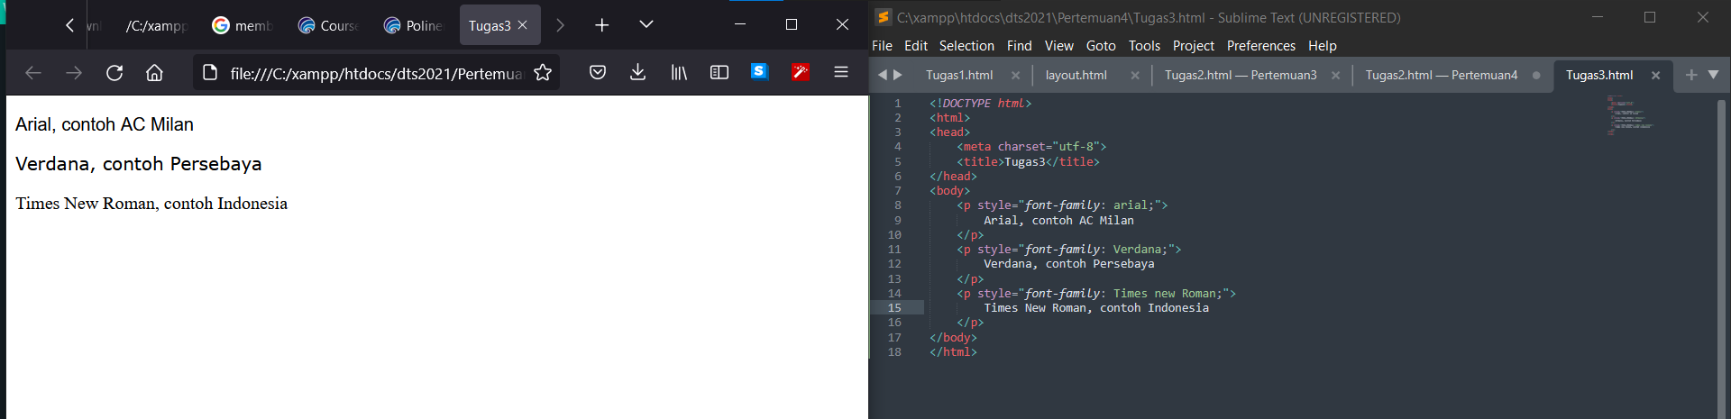

|  |
| --- |
| **<!DOCTYPE html>**  **<html>**  **<head>**  **<meta charset="utf-8">**  **<title>Tugas3</title>**  **</head>**  **<body>**  **<p style="font-family: arial;">**  **Arial, contoh AC Milan**  **</p>**  **<p style="font-family: Verdana;">**  **Verdana, contoh Persebaya**  **</p>**  **<p style="font-family: Times new Roman;">**  **Times New Roman, contoh Indonesia**  **</p>**  **</body>**  **</html>** |

**Nomer 4**

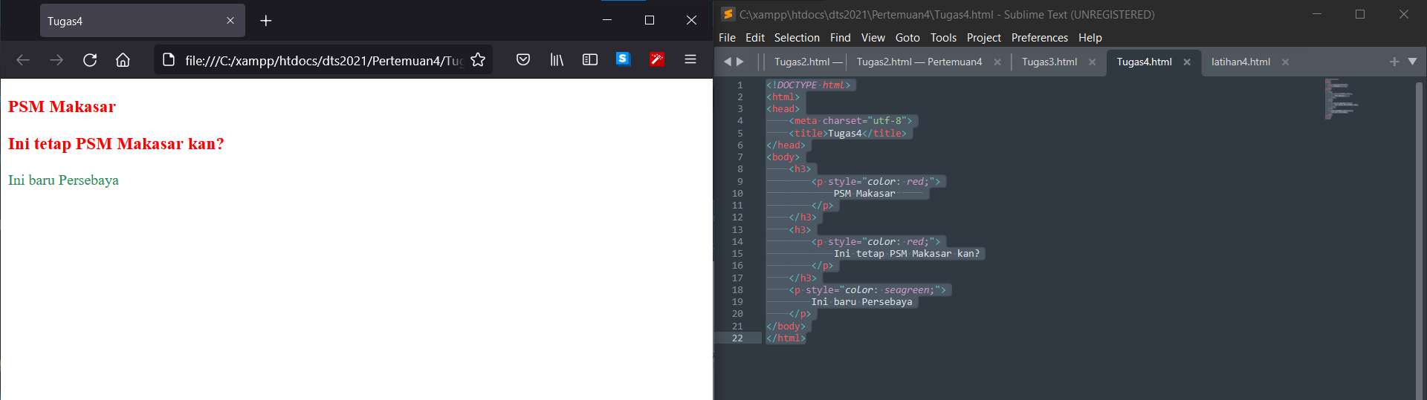

|  |
| --- |
| **<!DOCTYPE html>**  **<html>**  **<head>**  **<meta charset="utf-8">**  **<title>Tugas4</title>**  **</head>**  **<body>**  **<h3>**  **<p style="color: red;">**  **PSM Makasar**  **</p>**  **</h3>**  **<h3>**  **<p style="color: red;">**  **Ini tetap PSM Makasar kan?**  **</p>**  **</h3>**  **<p style="color: seagreen;">**  **Ini baru Persebaya**  **</p>**  **</body>**  **</html>** |